Sat, July 9, 2022 | GJ Forensic, LLC  Latest news and bulletin updates |  |  | Issue # 1
Gerardo Bloise, MPA ,CCSI  CEO GJ Forensic, LLC  The scoop of the day  The latest updates  Greetings, and welcome to other news and new topics on the GJ Forensics blog.  Today's topic will be fingerprints at the crime scene.  As a retired CSI from the Orange County Sheriff's Office, I worked several scenes where after inspecting them I observed shoe prints that prior to the investigation did not belong to either the victim or the first responders who arrived at the scene.  After having eliminate the shoes of the responders and the victim it was then obvious that this shoe mark was made by a person who was with the victim at some point. Here in this blog I will discuss the kinds of evidence features we call footprints.  At the crime scene you as an investigator could find traces of footwear, dirt, blood, paint, other types that when the sole of the shoe makes contact with some liquid or pasty material, stepping on it forms the shoe print.  Why are footprints important 􀂄  􀂄 Footprints and tire prints  When someone walks or runs, or drives a vehicle, over soil, impressions  are left in the ground. A frame is built around the print or track, a suitable  casting material is poured in and allowed to dry, and then the cast removed  and photographed. As shoes and tires are used, individual characteristics  such as nicks, cuts, and wear patterns develop. These characteristics may show  up in prints and impressions and can be compared with a suspect's  shoes or tires |  |  | 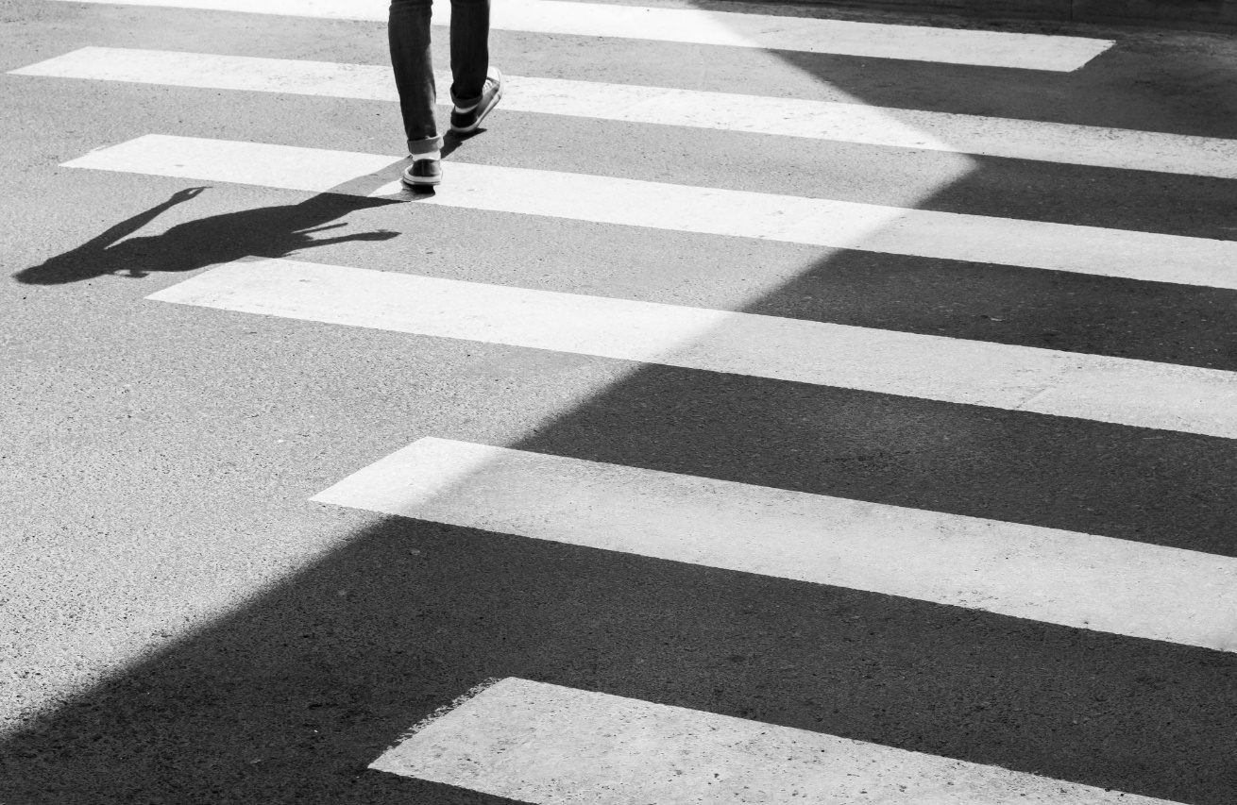
 |  |  | In the image above we see a person walking that person with his weight and his shoe would leave his mark on any surface. That indicates his presence in the places he steps on.
Gerardo Bloise, MPA,CCSI
Shoe Prints
CLASS AND INDIVIDUAL CHARACTERISTIC EVIDENCE
Class: a group of objects or persons with characteristic physical evidence common to it
Examples include soil and hair

Individual characteristics can be identified as having originated with a particular person or source establishes individuality examples include fingerprints and footprints.
PRESERVING FOOTWEAR AND:
IMPRESSIONS
􀂄􀂄 Footwear prints and impressions should be
photographed:
􀂄􀂄 As part of the general scene
􀂄􀂄 Also photograph with a scale
􀂄􀂄 Dental Stone is used in casting impressions
􀂄􀂄 We will use Plaster of Paris
FOOTWEAR IMPRESSIONS:
Photographs of footwear impressions at a crime scene:

􀂄􀂄 In the first photo only the impressions are shown
􀂄􀂄 In a subsequent photo a ruler will be added to show sizes
􀂄􀂄 Later casts will be made of the impressions
___________________________________________________________________
􀂄Footprints
Through the skillful combination of tracking and footwear impressions, it is
often possible to recreate the events leading up to, those occurring during,
and those occurring after the crime.
Collection of evidence

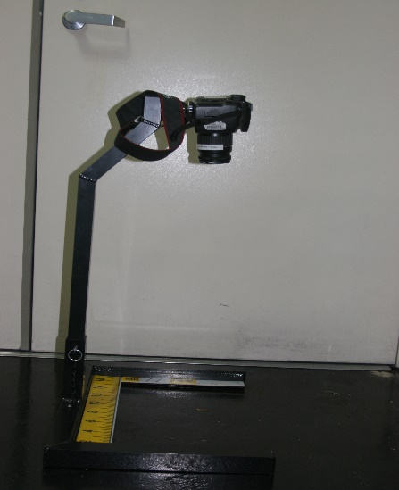
Photography:

Black and white film is normally used, unless the impression is in blood, and oblique light is shone onto the footprint. It is usual to take a series of photographs, each time varying the position of the light source, and a scale should be added to the scene. If the surface is light, the print may be highlighted using aerosol. The photo has to be 90ᵒ degree angle and you have to use a tripod. pa int.

How to make a casting
At the scene of the crime, a footprint is observed in the soil. Your
task is to make a cast of the footprint.
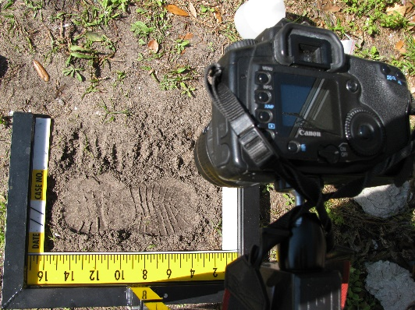
1. Make a dam around the impression of the footprint to hold the
plaster.

If the soil is of a loose sandy type, use shellac or hair spray to firm
the soil before pouring in the cast. Be careful in directing the spray of the "fixer" so that it does not blow
away the impression.

2 Mix the casting medium according to the instructions provided
(Dental Stone if available; Plaster of Paris, if not).
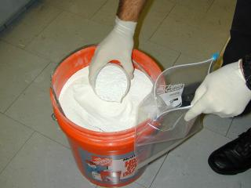
The ideal mixture should be pancake like pancake consistency

3. Pour the mixture carefully down a spatula to fill the entire
impression.

4 Allow the cast to set for at least an hour before removing it.

5 Comment on the characteristics of the shoe from which the
impression must have been made.
The impression can be compared with a shoe of the suspect,
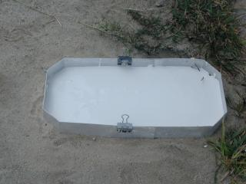
if one has been arrested.
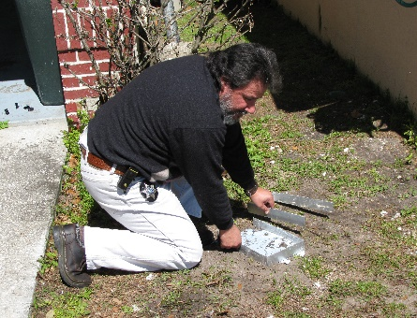
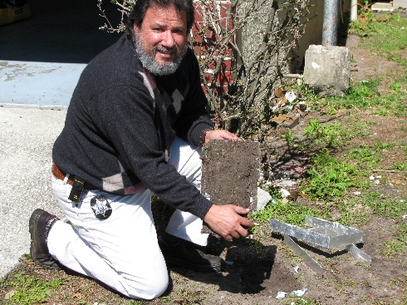

Footprint Analysis: What can they tell us?
- Footprint impressions from casts and/or by photography will give investigators information about:
- The number of criminals. 􀂄
- Points of entry and exit.
- Positions of suspect(s), victim(s) and
witness(es).
- Direction(s) of movement/travel and
pathway(s) through the crime scene.
- Time period, from short-lived impressions in frost, snow, dew.
BLOODY SHOE MARK
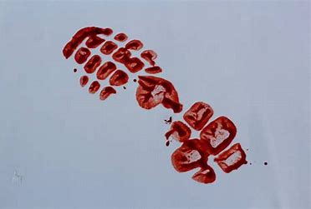

Dirt Shoe Mark
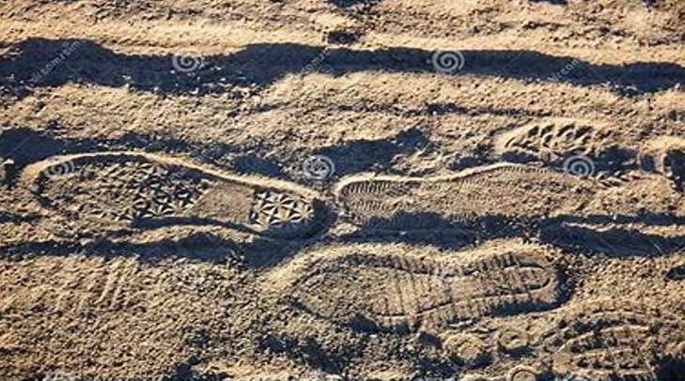

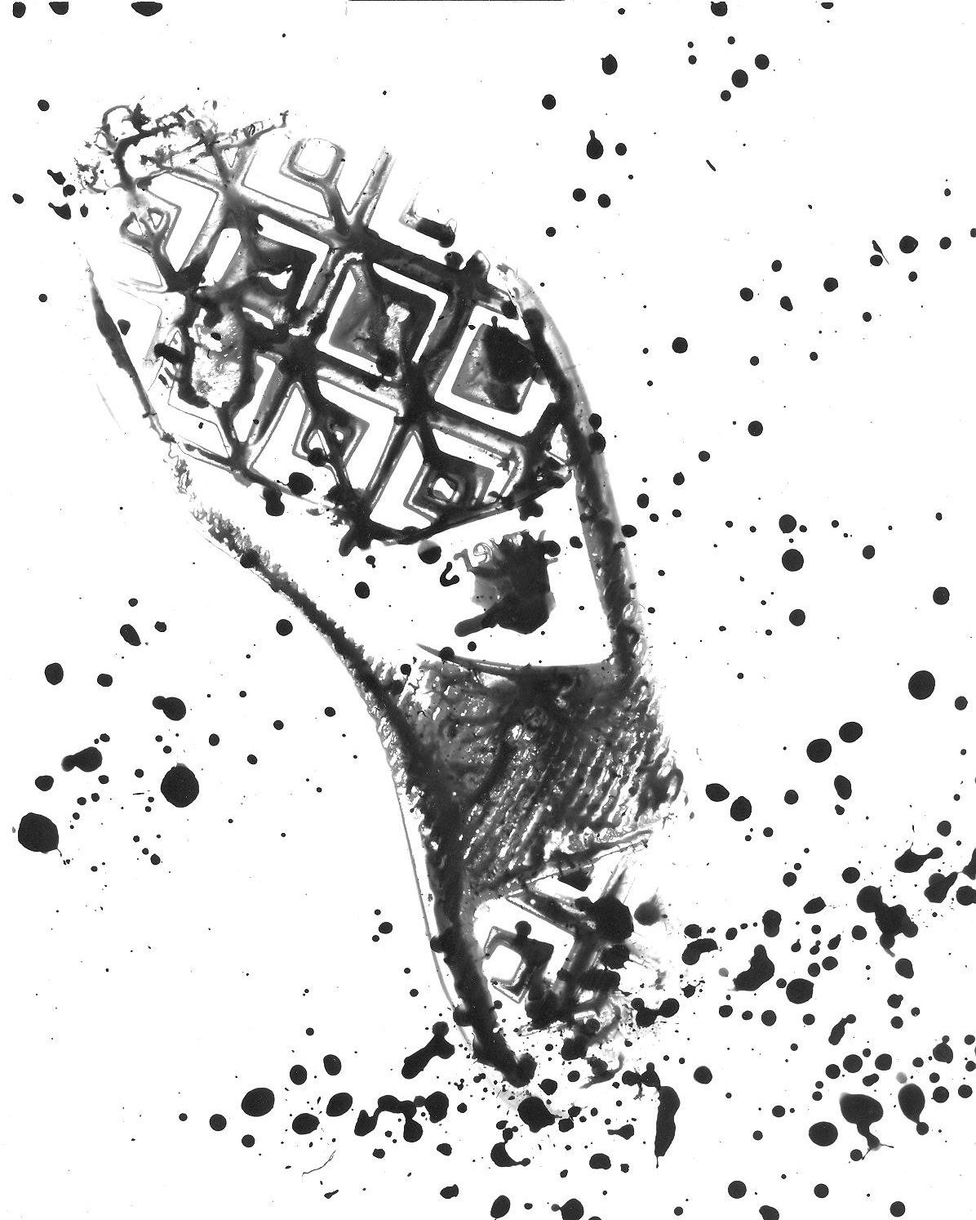

Black powder Shoe Mark

